Banner

https://s-media-cache-ak0.pinimg.com/originals/7e/ac/21/7eac217b7b1c55ab7fd56758e4e181be.jpgLogo



https://d3ui957tjb5bqd.cloudfront.net/images/screenshots/products/100/1001/1001971/preview001-f.jpg?1455715776

Mi principal activo es aprender

About me: I am a nice person with a lot of encouragement to learn and I like to learn about technology. My main motivacions are web development, artificial intelligence and data analysis. I like to play sports like athletics, basketball and I have a tendency to vegetarian diet. The vegetables are delicious. With respect to my personality are a reserved person

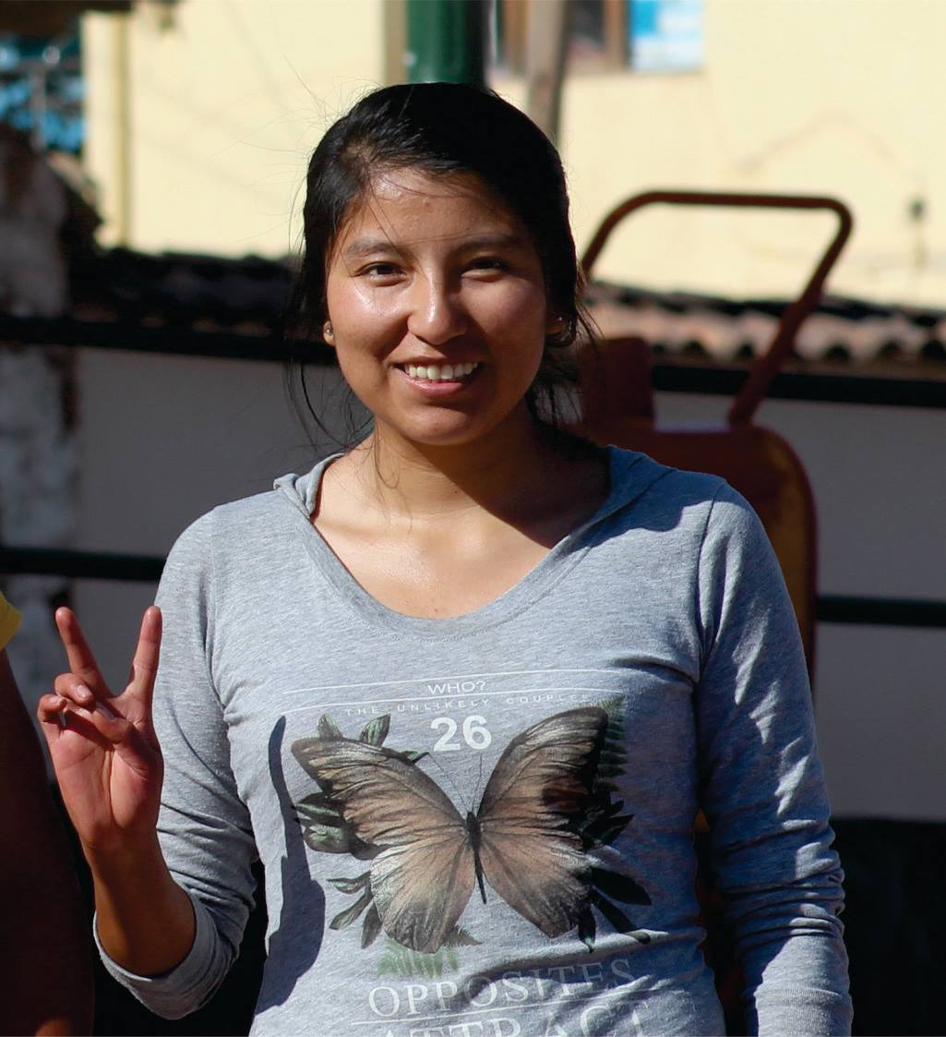

**Favorite thing:**



[**http://artprojectgroup.es/wp-content/artprojectgroup/programacion-web-a-medida.jpg**](http://artprojectgroup.es/wp-content/artprojectgroup/programacion-web-a-medida.jpg)



[**http://www.bestdoctorsblog.com/wp-content/uploads/2015/07/el-deporte-en-verano-587x346.png**](http://www.bestdoctorsblog.com/wp-content/uploads/2015/07/el-deporte-en-verano-587x346.png)

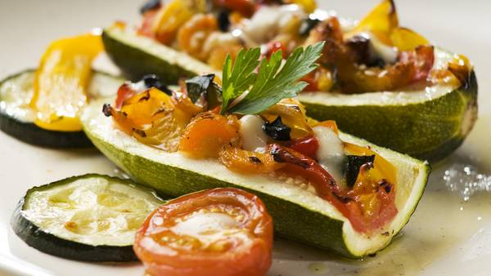

[**http://images.clarin.com/entremujeres/biencasero-comidas-rincon_gourmet-zapaliitos-rellenos_CLAIMA20150320_7808_27.jpg**](http://images.clarin.com/entremujeres/biencasero-comidas-rincon_gourmet-zapaliitos-rellenos_CLAIMA20150320_7808_27.jpg)



**http://www.proyectopv.org/imagen/prosperidad.jpg**